L2 or L3 or tests name: IT-Operation Management
Legal entities in scope: DBAG, ExR, EFAG, ECAG, CBF, CBL, LuxCSD, CI, CS and CFCL
IT Asset Management, Configuration Management
Out of Scope - Licence Management

[+ including AU-121-11-CSDR CSDR IT-Operation Management]

Test(s) according to RCA:

(TP1) Inquire with relevant personnel about the implemented structure and process regarding the IT Asset / IT Configuration Management process.
(TP2) Review related policies and procedures against the information received about the process and controls to validate whether the formal definition is in line with the current process and ensure the up-to-datedness.
(TP3) Perform a testing based on a representative sample for the IT Asset Management and IT Configuration Management processes, whether the process and controls are established as detailed (focus on the IT Application allocated and identified as relevant for this Audit).
(TP4) Test the related Future Notes identified as relevant - FuN: 211217153616 and FuN: 240313110328

FuN: 211217153616
“During audit on IT infrastructure (2021-044), it was identified that centralized SAP based tool for IT asset change request is established on DBG level (ISR tool). It facilitates request for new IT asset e.g. new server. In case the requested server is based on virtual infrastructure, additional request must be made in JIRA. Since these applications are not connected, this requires duplicate effort for entry of request data as well as for maintenance of the workflow tools (e.g. support groups and approval levels). IA also understood that other IT shops within DBG follow the same approach of separate JIRA solutions (e.g. Corporate IT).
It should be checked if centralization of the IT asset request processing is possible or interface between the tools can be built. Owner of the ISR tool is Sean Mc Taggart (I&O Department).
For details, please see WP on virtualisation from 2021-044 audit.”
FuN related LEs: DBAG, ECAG, CBF, CBL, CFCL

FuN: 240313110328
“Please test the IT Asset Management Process to the full extent next year (only high level for 2024) - special focus on identification, assessment and allocation on criticality to the IT asset.”
FuN related LEs: DBAG, ECAG, CBF, CBL, CFCL

Audit procedures/source:
- Information directly requested from auditee (via e-mail or call) or extracted from provided documentation during preparation phase.

Conclusion:
Ok, no exception identified

Internal audit (FM, DH) has performed the following Audit procedures:

(TP1)
Discussing with the Head of IT Core Process Design & Operations (U) we were able to understand that there are no significant changes to the process since last time it was audited.

APMS Main Processes (workflow)
- Application Portfolio Management System (APMS) User Manual v1.2
- APMS Mandatory Attributes v2.7
- APMS Onboarding Procedure Guideline
- IT Asset Management Process v 1.10

- Add new Application
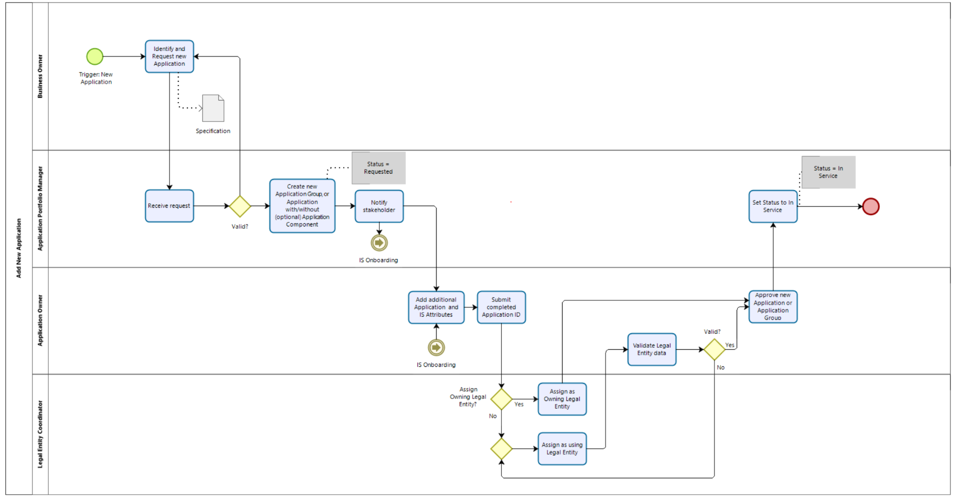
- Maintain Application
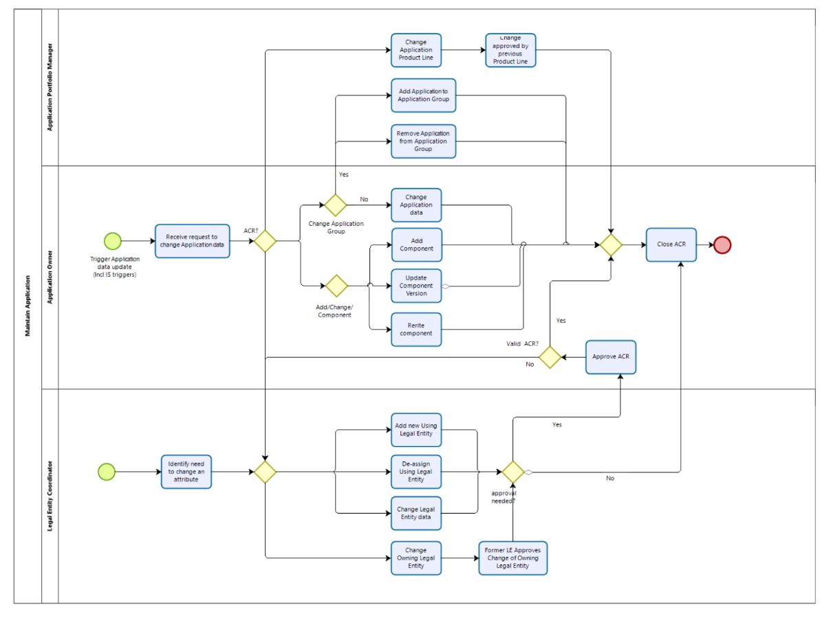
- Retire Application
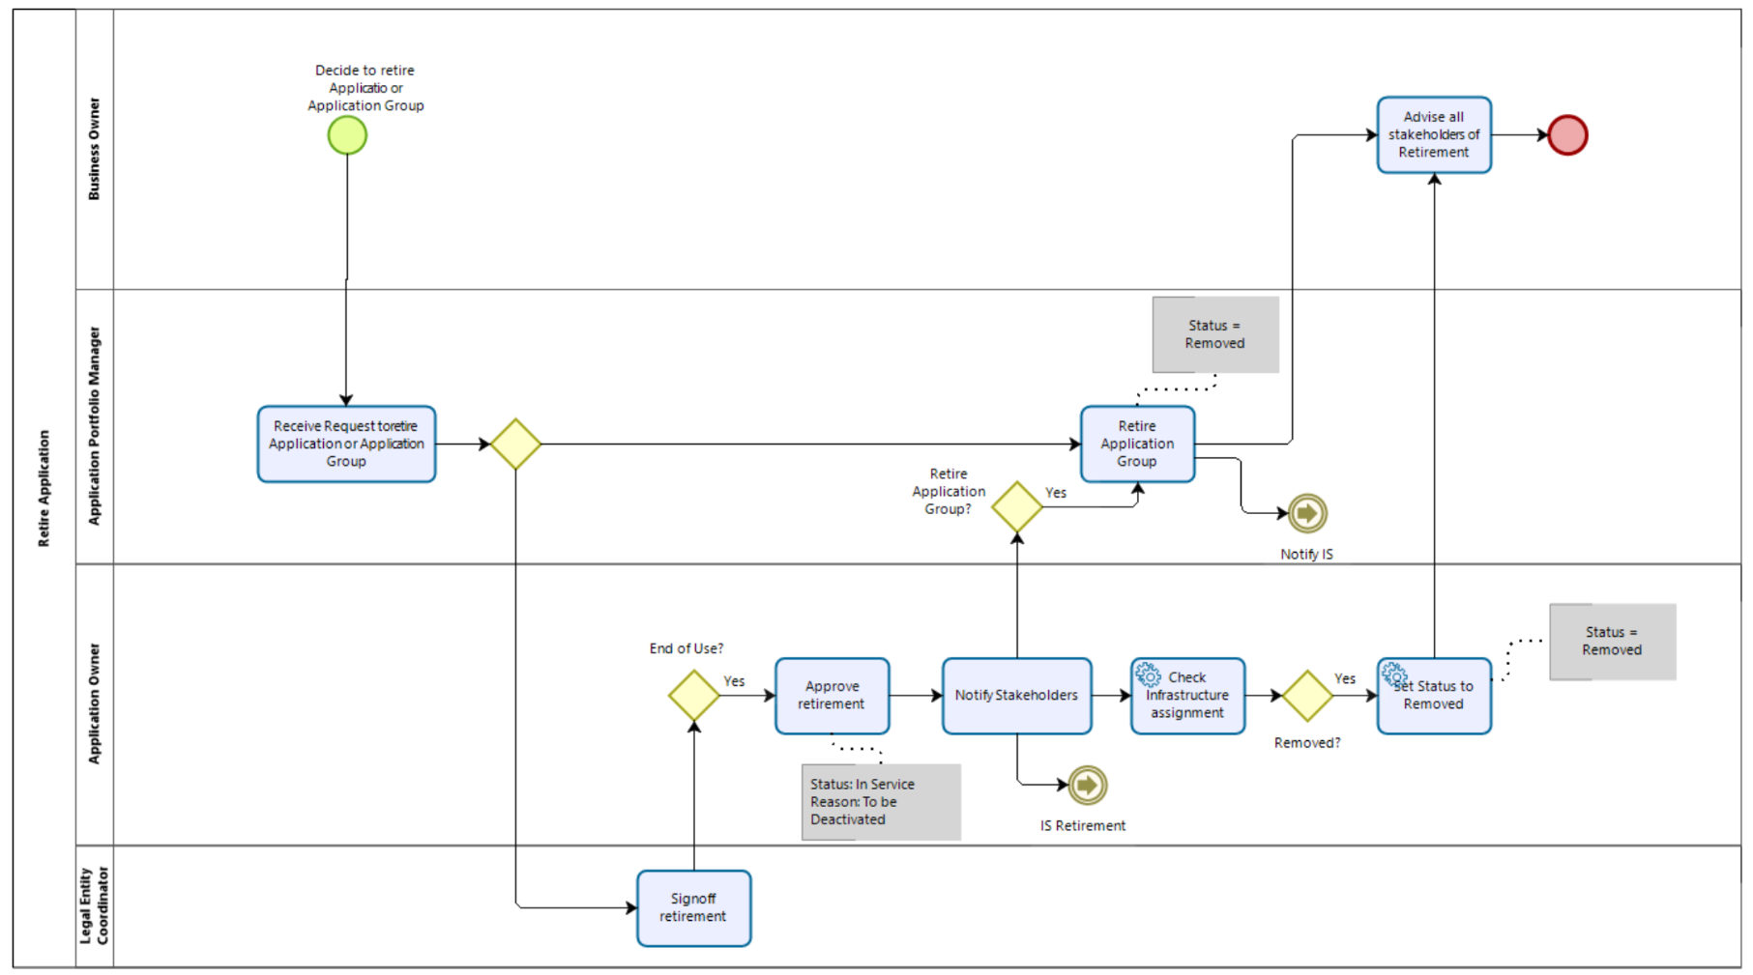

Configuration Management Processes (workflow)
- Configuration Management Process v1.8
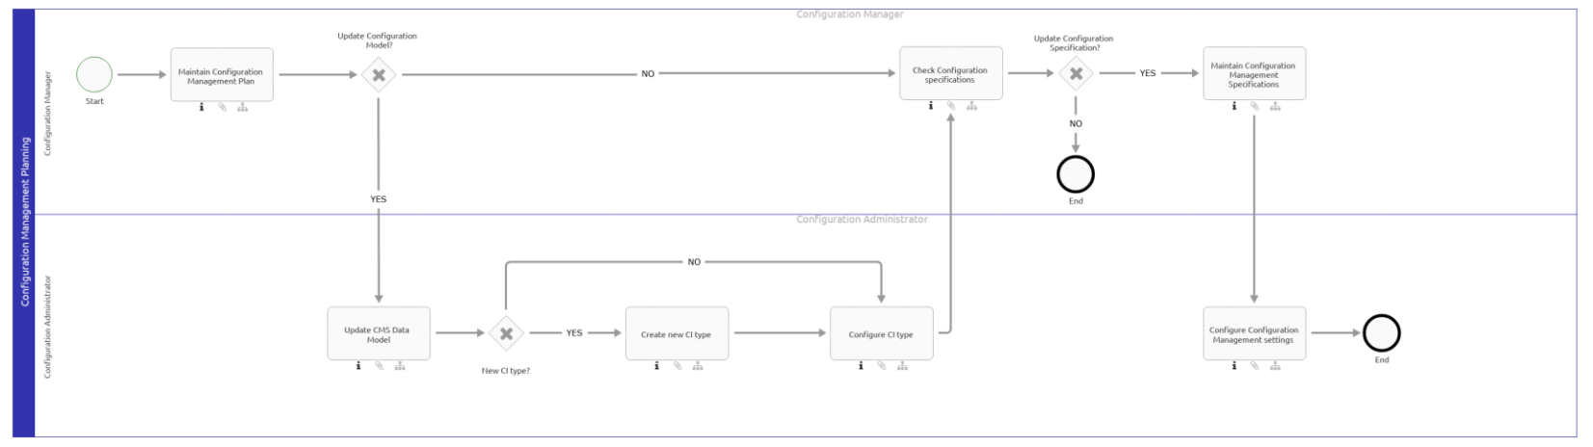

(TP2)
As of 2025, the ICT Risk Framework includes the second level documents (the ICT Risk Guidelines) that are subordinate to the ICT Risk Policy and integrates the Information Security and IT frameworks into one:
ICT Risk Management Policy
ICT Asset Management Guideline

The below was replaced by the above documents (Old)
DBG_IT Asset Management Standard_v1.13.pdf
DBG_IT Asset Management_Guideline_v2.2 .pdf

Regarding the underlining documents, we noticed that it doesn’t reflect the new ICT Asset Management Guideline, however, this is currently been remediate as part of the Recommendation Number 2024-063_F01-A01 / 2024-063_F01-A03, related to the S3 finding “Incomplete ICT Risk Management framework and lack of harmonisation between DBG’s first and second LoD" raised in the “2024-063 Technology Governance” report. Alos, CAP can be found here.
Configuration Management Process v1.8
IT Asset Management Process v 1.10
IT Infrastructure Change Management Process v1.8
Infrastructure Service Request User Guide v3.1

(TP3) We confirmed that the below active 1LoD controls are in place for a sample of 1 ITAM-023 APMS Data Quality insuring that the gaps identified in column “F” on tab “ITAM-023 APMS APPL Data” were followed up.

In addition, we confirmed that the ITAM KPI Reports per legal entity are generated weekly and mitigation actions are put in place in case of KPI breaches (here):
- AM1: Consistency between Financial Asset Inventory and Physical Asset Inventory
- AM2: Consistency between SAP CMS and Financial Asset Inventory
- CM1: Completeness of Configuration Item mandatory attributes in CMS
- CM2: Correctness of Configuration Items in CMS (Orphans)
- CM3: Correctness of Configuration Items in CMS (Duplicates)
- CM4: Compliance of Configuration Item data (expected vs. actual values)

However, it’s clear that the processes have gaps that were identified during the BaFin and CSSF audits:

Findings details here.

and it’s currently being addressed in the Ameli project:
  - ITAM high-level impact analysis:
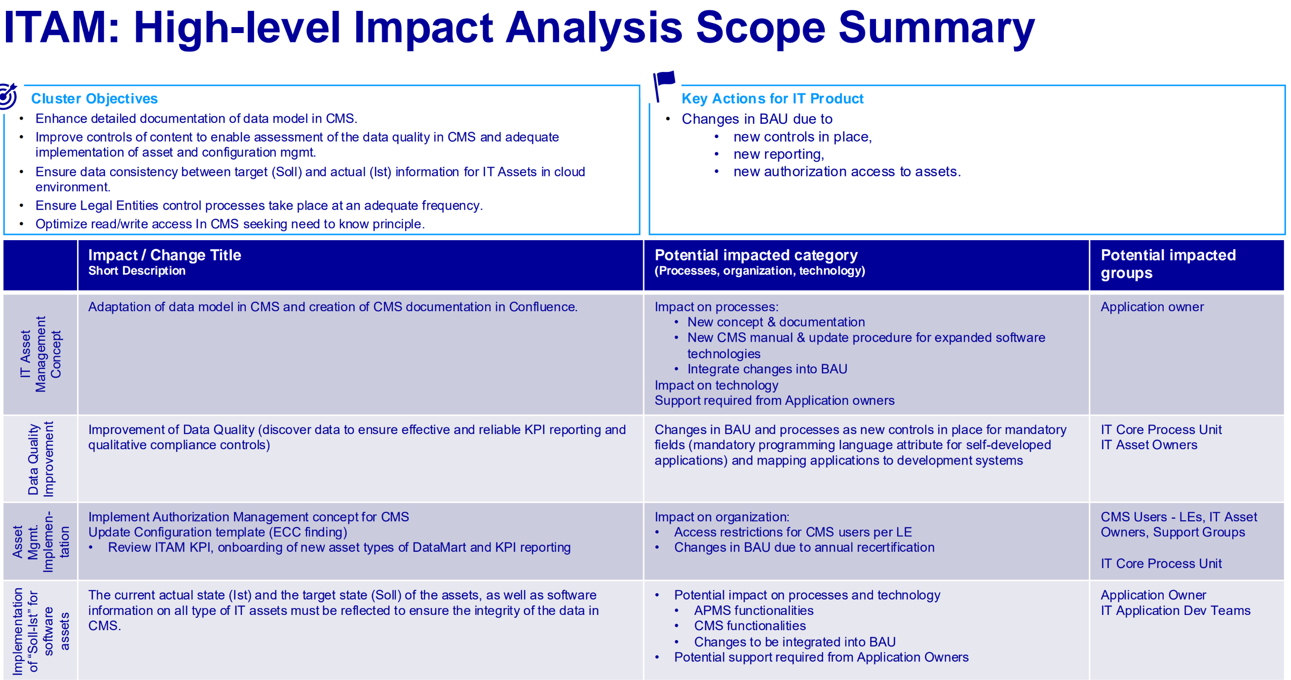
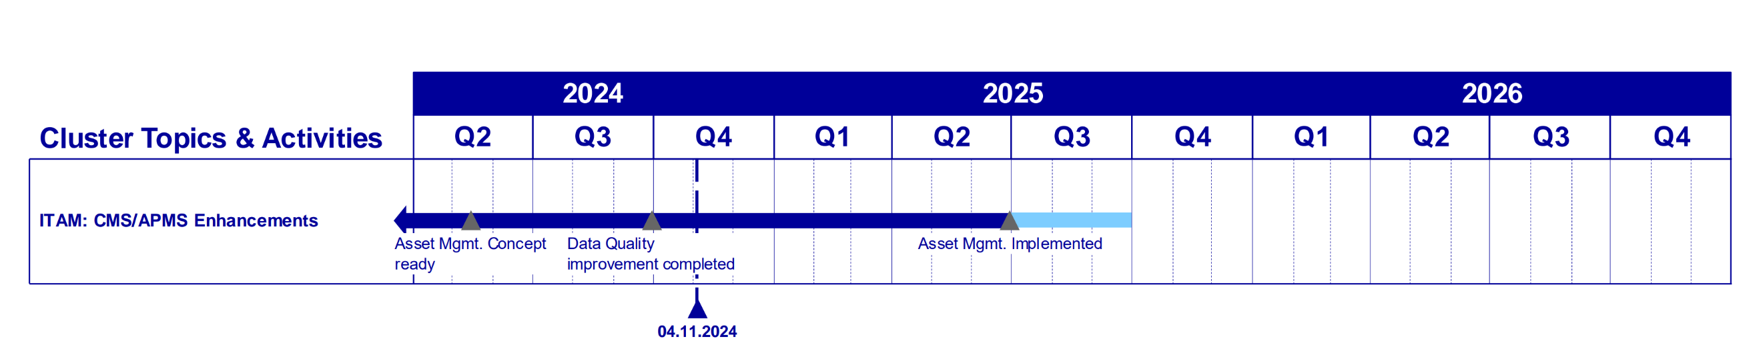
  - ITAM Ameli deliverables
  - ITAM Cluster weekly status update
  - How-to-close the finding document_ITAM

Note: testing related to application IS Classification is covered in (TP4)

(TP4)
FuN: 211217153616

The ISR process is described in the IT Infrastructure Change Management Process v1.8 and Infrastructure Service Request User Guide v3.1.
As confirmed with Thierry Aglat from Virtualization Services (U), Virtual Devices assets ISR follow the same process that the other type of assets.
What the future note is referring is the Task (Implementation of Change) that is handled in VM Provisioning - Service project (JIRA) for his team.
Every Support Group when receiving an ISR must trigger the Task to the relevant team depending on the asset. For Virtual Devices, as mentioned previously, this is done in a JIRA instance: teams do not need to use a central tool to manage their requests, and normally is not in the ISR tool (CRM7) due to the cost and complexity to implement such workflow in SAP.

However, since this topic it is not related to IT Operations, I relocated this FN to the bellow audit:
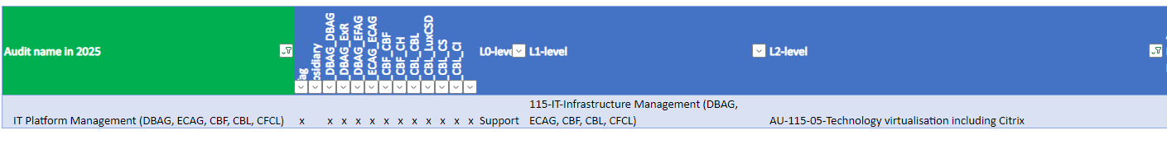

FuN: 240313110328

Regarding the Criticality, the ICT Asset Management Guideline state the following:
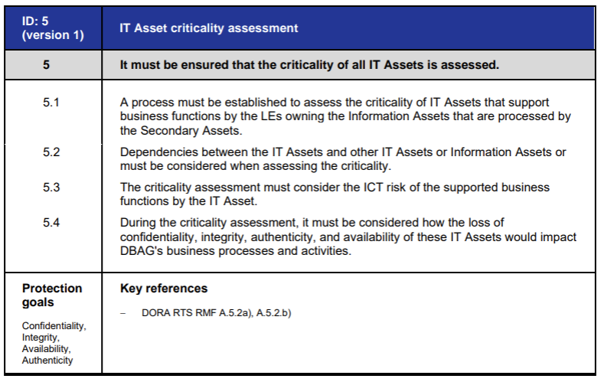
The IT Asset Management Process v 1.10 do not specify this step, however it is described in the 03_Application Portfolio Management System_User Manual_v1.2.pdf:
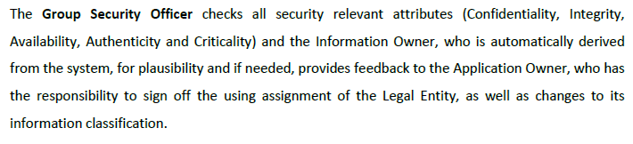

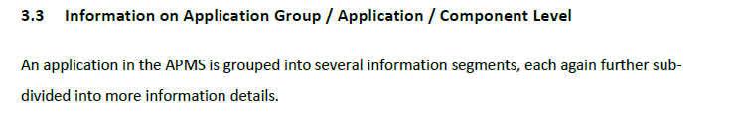
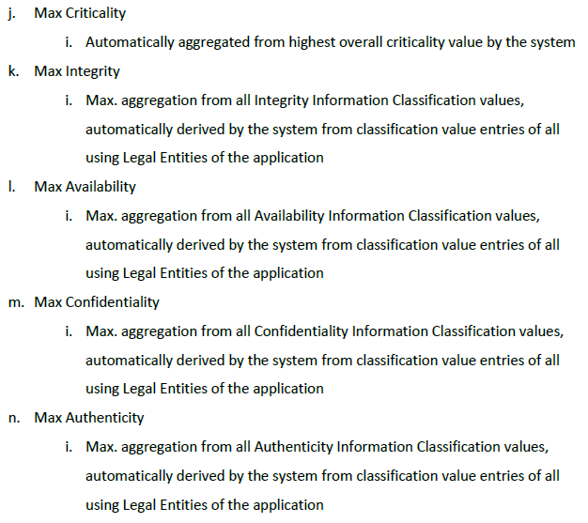
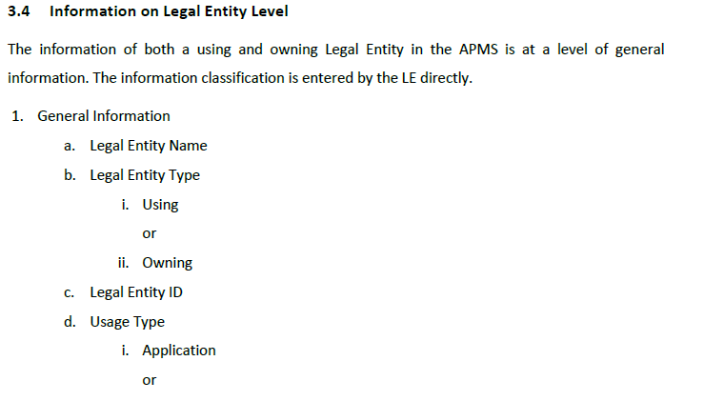
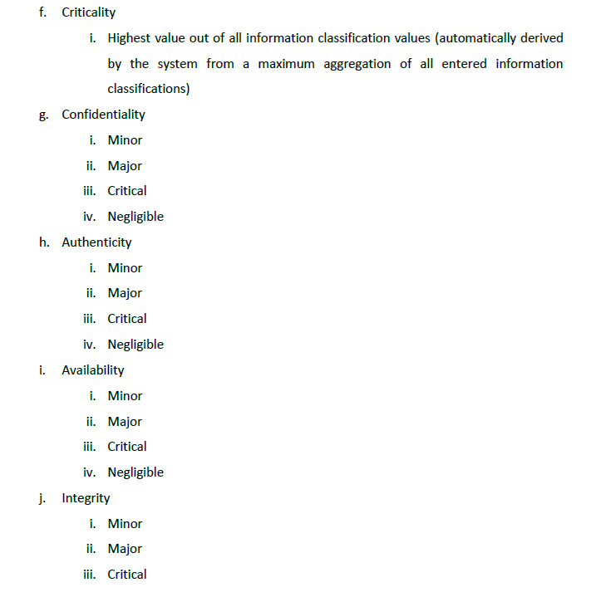
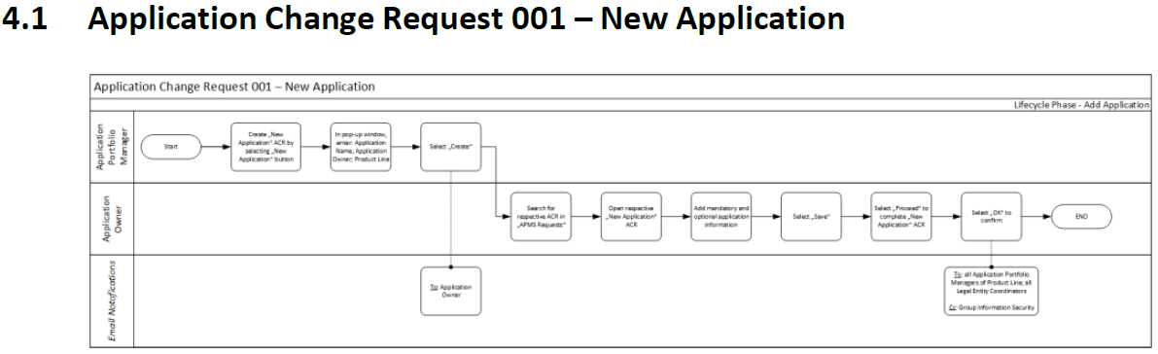

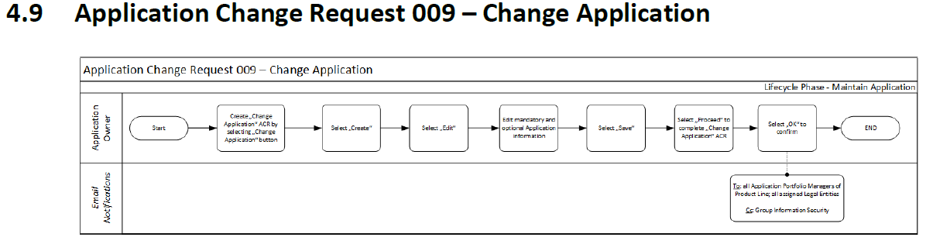
Also, the Information Classification process flow is described here and the documentation used here.
This process is part of the overall Information Risk Management Lifecyle:
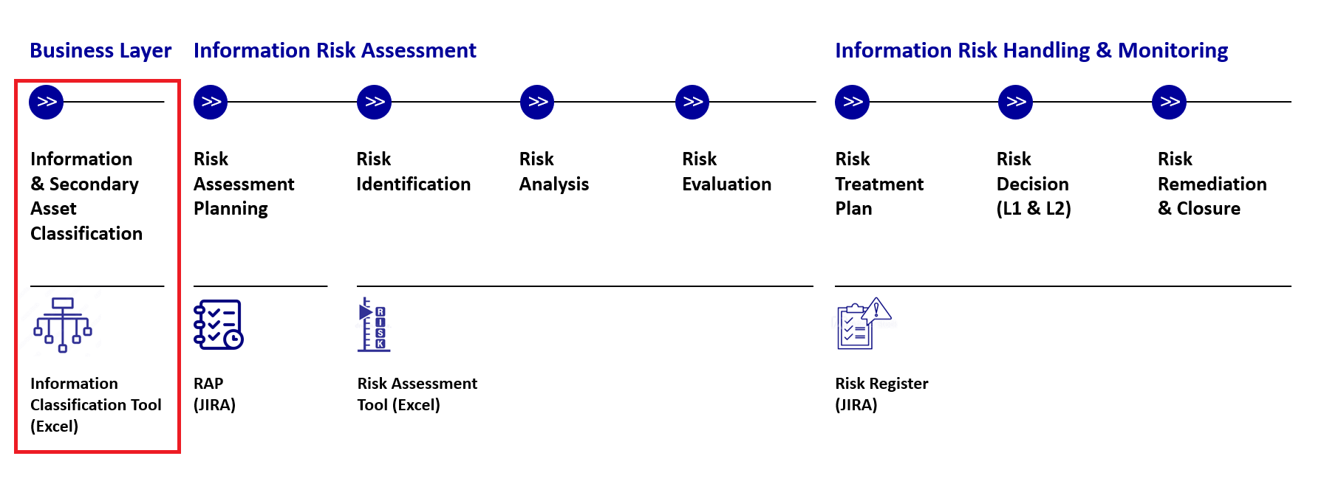

As Operating Effectiveness, we assess and confirmed that all Applications in APMS were classified by the LE: CMS Applications LEU_APP Criticality.xlsx
Also, confirmed (inside the excel in green) that the Classification of information (below security concept section) was performed, for the applications in scope.
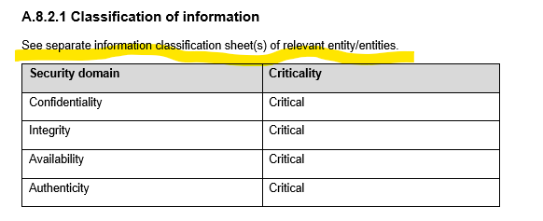
AID | Application | Owner
AID937 | Brocade SAN | @Benedicte Clotuche
AID938 | EMC Storage | @Benedicte Clotuche
AID940 | NetApp Storage | @Benedicte Clotuche
AID941 | Storage support tools | @Benedicte Clotuche
AID2119 | XEOPS Storage Operation | @Thomas Reich
AID2039 | XEOPs SAN RM | @Thomas Reich
AID2010 | FCBS | @Bishwamitra Thakur

In addition, below explanation of the Attribute Inheritance setup in CMS:

-------------------------------------------------------
Summary of work done:
-------------------------------------------------------

AP | Work done | Result
TP1 |  | OK
TP2 |  | OK
TP3 |  | OK
TP4 | FuN: 211217153616 | OK
TP4 | FuN: 240313110328 | OK

Self-Identified Issue (SII):

Additionally, Internal Audit was provided during the late stage of the fieldwork phase with a Self-Identified Issue from the Cloud Area, which is related to the Asset Management and the Container that are established in the Cloud. Furthermore, it was reported that there is no specific government arrangement defined in the context of containerization for the cloud and no identification measures of software in the container infrastructure were available. Additionally, it was reported that there is the probability of having high privileges in the container infrastructure which have not removed/revoked before the shift to the cloud via the secure landing zones. The topic was identified during an ITG Committee Meeting in January 2025. Further analysis are currently ongoing, measures to remediate were already identified and started. Monitoring is currently done on a monthly basis basis by Management in the ITGCs.

Meetings held:
20th March 2025: M. Girg (Head of Chief Cloud Officer)
24th March 2025: M. Girg (Head of Chief Cloud Officer)
24th March 2025: B. Link (Head of IT Governance, Risk and Transformation)

Information provided:
Email Boris Link 24th March 2025 on the SIIs recorded in AMIT, with the exact details.

The finding received was agreed upon by the involved parties and drafted in the final report.

